Site Category

Customer wants this attribute in the Site Report where he wants to import manual data.
So, this attribute should come under CSV and manual edit import pannel for the Site report.
Kindly note that this attribute shouldn’t be restricted to predefined values.
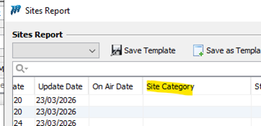

- Role of Site Category
The Site Category column will be used to identify and classify the type of site for reference purposes in the detailed sites report.
Examples of Site Categories include:
- Buildings
- Warehouses
- Offices
- Administrative locations
- Storage facilities
- Non-network or passive locations
Site Category will not drive any automated status changes.

Any change/update request should be generated at WF as pending modification.

